Rigging Information

- The rigging point has to be on a square heavyweight truss or steel bar/beam which can take
a load capacity of minimum 400kg per performer. For Double-Acts the load capacity doubles.
- The truss or bar where the rigging point is located should be free from any other objects.
- To reach the rigging point, a scissor lift or ladder has to be provided in order to access the installation.
- Performance area underneath the aerial point: Per Aerialist: min 4m x 4m / Aerial Sling Duo: min 5m x 5m
- Requested roof height (from stage): min. 5-8m (Aerial Silk/ Slings/ Straps/ Aerial Net/ Corde Lisse/ Trapeze) Static Aerial Hoop (Lyra): min. 4m
I.
Static Aerial Acts
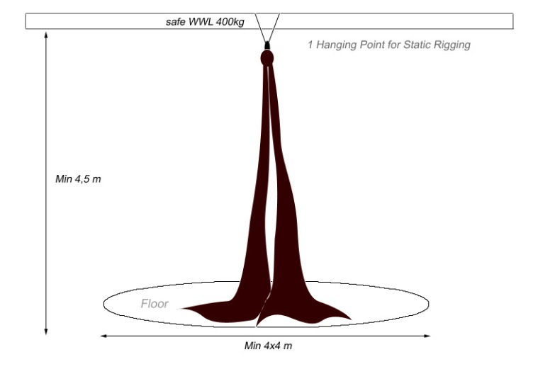
For a static Aerial Act, simple and basic rigging is used. It does require only 1 rigging point and there is no additional attachment points needed. A rope can be used to tie away the aerial apparatus before after the act.
II.
Pulley System & Counterweight
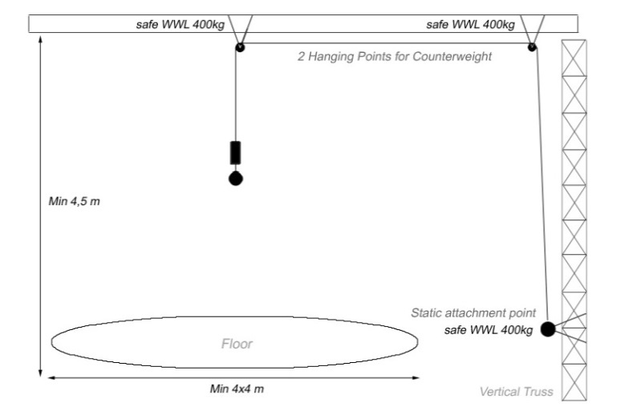
With the pulley-system the aerial point can be lowered and raised. For Counterweight an additional climbing possibility, e.g. a fixed ladder, vertical truss or rope can be used by an offstage performer or rigger to control the motions while suspended on the same line.
Pulley System & Counterweight
- For a pulley system 2 rigging points and 1 attachment-point on the ground, wall or vertical truss are required. Each of the 3 points needs to have a safe WWL of 400kg.
- For the Counterweight System, the pulleys and a fixed/strapped ladder or a vertical truss is required to climb up and down in order to counterbalance/lift the aerialist.

